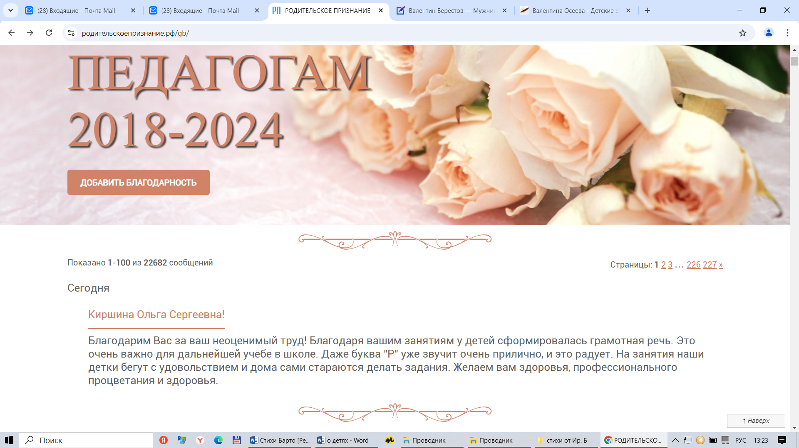

<https://xn--80ahdabkeccpk2abdfrijor6s.xn--p1ai/gb/>

